


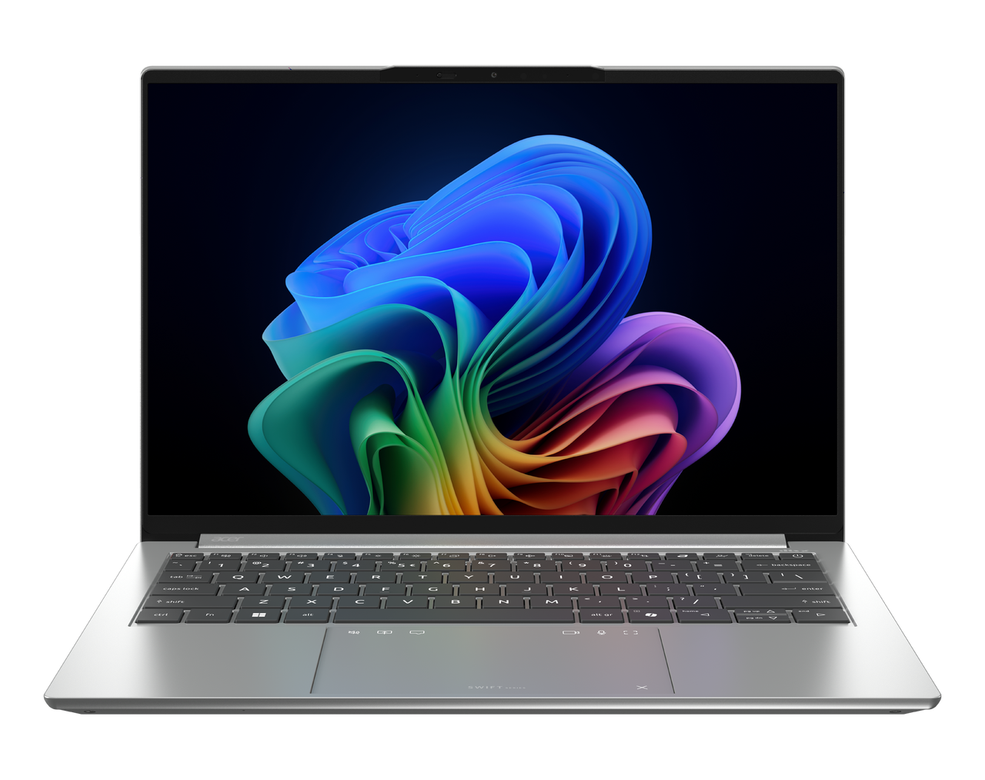

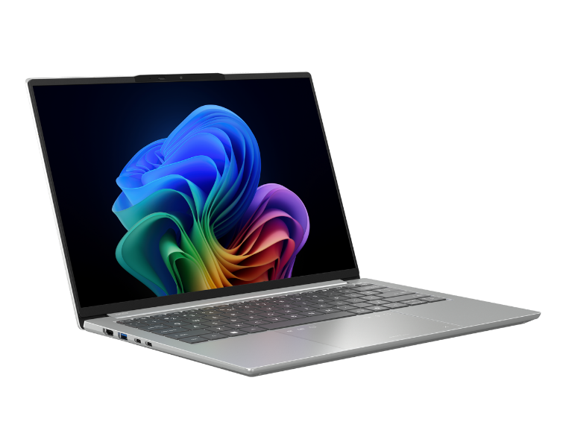
Acer Swift Go14 AI
I
SPECIFICATIONS Swift Go 14 AI SFG14-I71 | SFG14-I71T
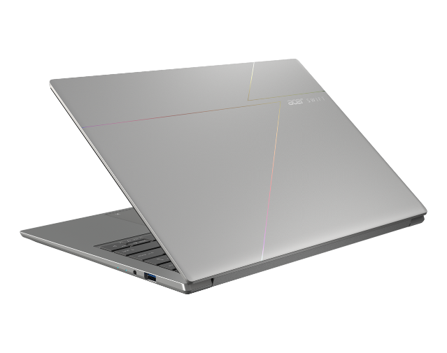
2
1
3
4
1

5
12
11

16
15
13
14
Product views | - Microphones  - Camera shutter  - Camera  - IR Camera  - 14" display  - HDMI port | - USB 3.2 Gen 1 port with power-off charging  - USB Type-C / Thunderbolt™ 4 port  - USB Type-C / Thunderbolt™ 4 port  - Touchpad  - Keyboard  - Power button |  |  | - Power indicator  - Battery indicator  - Headset / Speaker jack  - USB 3.2 port
Operating system¹ | Windows 11 Home
CPU and chipset¹ | Intel® Core™ Ultra X7 processor 358H  Intel® Core™ Ultra 7 processor 356H  Intel® Core™ Ultra 5 processor 338H  Intel® Core™ Ultra X9 processor 388H  Intel® Core™ Ultra 9 processor 386H |  |  | Intel® Core™ Ultra 5 processor 322  Intel® Core™ Ultra 5 processor 325  Intel® Core™ Ultra 7 processor 355
Memory^{1, 2, 3} | Dual-channel LPDDR5X SDRAM support  - 16/24/32 GB of onboard LPDDR5X system memory  - Up to 7467 MT/s
Display⁴ | SFG14-I71  14.0" display with OLED (Organic Light-Emitting Diode) technology, WQXGA 2880 x 1800, high-brightness (400 nits, typical value) Acer CineCrystal™  - 16:10 aspect ratio, color gamut DCI-P3 100%(Typical value), certified by True Black HDR 500(@HDR 500, brightness reach 500 nits)  - Wide viewing angle up to 170 degrees  - Mercury free, environment friendly  14.0" display with OLED (Organic Light-Emitting Diode) technology, WQXGA+ 2880 x 1800, high-brightness (400 nits) Acer CineCrystal™  - 16:10 aspect ratio, color gamut DCI-P3 100%, certified by True Black HDR 500(@HDR 500, brightness reach 500 nits)  - Wide viewing angle up to 170 degrees  - Mercury free, environment friendly |  |  | SFG14-I71T  14" display with OLED (Organic Light-Emitting Diode) technology, WUXGA 1920 x 1200, Brightness (250 nits)  - 16:10 aspect ratio, color gamut DCI-P3 95% with integrated multi-touch  - Wide viewing angle up to 85 degrees  - Mercury free, environment friendly
Graphics^{1.5} | - Intel® Arc™ B390 GPU eligible |  |  | - Intel® ARC™ Graphics 130V
Audio | - DTS® X:Ultra Audio, featuring optimized Bass, Loudness, Speaker Protection with up to 6 custom content modes via smart amplifier  - Supported in Windows Spatial Sound for PC Gaming with DTS Sound Unbound license integrated  - Immersive audio rendering over headphones and internal speakers  - High SNR DAC with 2.1 Vrms out capability and can driver high impedance headphone (up to 600 ohm)  - Acer Purified.Voice technology with AI noise reduction in 3 mics array built-in microphones to support Advanced Privacy Mode. Features include far-field pickup, dynamic noise reduction through neural network, adaptive beam forming, and pre-defined personal and conference call modes.  - Compatible with Cortana with Voice  - Acer TrueHarmony Technology for lower distortion, wider frequency range, headphone-like audio and powerful sound  - Hi-Res Audio Certification by JAS ( Headphone Output setting supported up to 24bit /192KHz)  - Soundwire Codec with MSFT SDCA 1.0 driver supported
Storage^{1, 6} | Solid state drive  - 512 GB / 1 TB, PCIe Gen4, 16 Gb/s, NVMe  - SSD Slot: 1
Webcam¹ | Video conferencing  UFC with:  - Double T-Type USB 5M +IR Camera  - •Compatible with Windows only  - •2880 x 1800 Resolution  - •1800p 5M Video at 30 FPS with Temporal Noise Reduction  - •Staggered High Dynamic Range (SHDR) |  | - •Dual Mic (33 mm + 33 mm)  - •86 x 3.2 (4.2) x 3 mm  - •Blue glass lens  - •IR 940nm
Wireless and networking¹ | WLAN  - Intel® Wi-Fi 7 Wireless LAN  - 802.11 a/b/g/n/ac/ax/be  - Band: 2.4 GHz, 5 GHz, and 6 GHz |  |  | - 2x2 MIMO technology  - Intel® Connectivity Performance Suite (ICPS)  WPAN  - Supports Bluetooth® 5.4 or above
Dimensions and weight^{7,8} | Dimensions: 310.5 (W) x 218.9 (D) x 10.4/15.6 (H) mm (12.22 x 8.62 x 0.41/0.61 inches) |  |  | Weight: 1.12 kg (2.47 lbs.) with 4-cell battery pack
Power adapter and battery^{9.10} | SFG14-I71  Power adapter  3-pin 100 W PD PCR 50%, TCO 9.0 AC adapter  Battery:  NA |  |  | SFG14-I71T  Power adapter  3-pin 100 W PD PCR 50%, TCO 9.0 AC adapter  Battery:  NA
Input and control | Keyboard  81 (UI)-/82 (UK)-key Acer backlight keyboard layout with multiple international language support, SR03P  Slim design with 1.3 mm key travel  AcerSense app support  Programmable “My” key  AI function activation indicator (Copilot)  Enlarged keycaps for improved typing comfort  Optimized backlight brightness for better legibility  Quiet, low-noise design  Titanium metal frame support |  |  | Caps Lock and Microphone Mute indicator lights  Function lock for user-defined hotkey preferences  TouchPad  Multi-gesture Lighting touchpad, supporting two-finger scroll; pinch; gestures to open Cortana, Action Center, multitasking; application commands  Multi-control Lighting touchpad  Microsoft Precision Touchpad certification  Moisture resistant  Corning® Gorilla® Glass
Windows Desktop Apps¹¹ | Acer AI Image Generator  Acer AlterView  Acer LiveArt  Acer ORD Service  Acer QuickPanel |  |  | Acer VisionArt  Search  AcerSense  Tools  Acer My Key Application
Warranty | One-year International Travelers Warranty (ITW)
- Specifications vary depending on model.
- Shared system memory may be allocated to support graphics, depending on system memory size and other factors. Actual system memory available to the operating system will be reduced by any memory used by the graphics solution and resources required by the operating environment.
- Memory speed may vary, depending on the CPU, chipset or memory fitted.
- All brands and product names mentioned herein include trademarks of their respective companies and are used solely to describe or identify the products.
- Not all features indicated are supported on all SKUs
- 1 GB is 1 billion bytes. Actual formatted capacity is less and may vary depending on preloaded materials and operating environment. Acer Recovery Management uses a portion of the stated hard disk capacity as dedicated backup space.
- Minor variations in system dimensions are possible due to the manufacturing process.
- Weight may vary depending on product configuration, vendor components, manufacturing variability, and selected options.
- Listed battery life is based on testing using Web browsing. The test clip loops the loading of 50 selected websites using Microsoft Edge every 30 seconds, until the battery is drained. Stated battery life is for comparison purpose only. Actual battery life varies by model, configuration, applications, video chip format and features used. A battery's maximum capacity decreases with time and use. Battery life test configuration: Intel® ULTRA 7 (Series 1), FHD, SSD only, 16GB of LPDDR5X memory. Battery life test condition: 100 nits LCD brightness, 50% speaker volume, WLAN on, Bluetooth on, no WW direct Internet connection.
- Actual battery life may vary considerably by specifications, depending on product model, configuration, applications, power management settings, operating conditions, and features utilized. Performance variation also arises based on components in use, which includes but is not limited to the processor, RAM capacity, storage, display and resolution, etc.
- Bundled software may vary depending on hardware configuration, OS and regional availability.

Note: This specification is based on Swift SFG14-I71 (Win11) Specifications (v1-0-0) (Preview) | Swift SFG14-I71T (Win11) Specifications (v1-0-0) (Preview),

101
1
8
7
6
9

